Cruise Control Switch – CGEA1.3

Functional Description

The purpose of the Cruise control Switch STSS is to transmit the proper cruise control state to the PCM module over a CAN signal. The cruise control switch is an analog input hardwired to the cluster. This input is translated to a CAN signal.

The set of cruise control switches is controlled via a resistive ladder which provides an analog input to the micro. The micro converts the resistance into A/D counts for each of the switches and determines which switch has been pressed.

This STSS is to be implemented only on those programs where the cruise control switch is hardwired to the cluster.

Interfaces

Interface Context Diagram (I/O Block Diagram)
- Cruise Control Switch Function

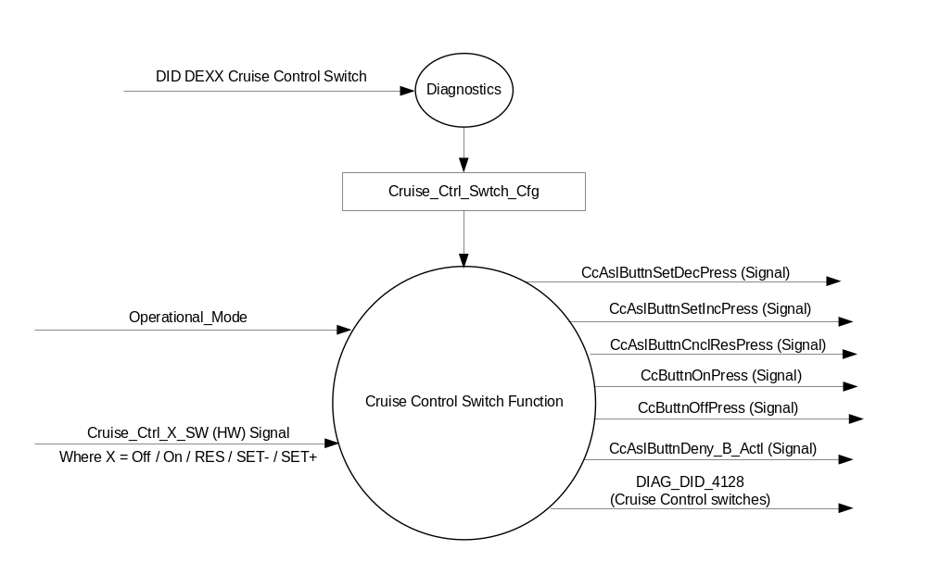

Inputs

      - INTERNAL:
            - Operational_Mode
            - DIAG_DID_4128, 2 bytes (Cruise Control Switches)

      - Cruise_Ctrl_OFF_SW_Status (HW) Signal:
To be sensed by a micro A/D port
Resistance ( in Ohms) | A/D Range (10 bit) | CC OFF switch Condition | CC RES switch Condition | CC SET- switch Condition | CC SET+ switch Condition | CC ON switch Condition | CC Fault switch Condition | Debounced State
0 - 25 | 0 - 27 | Pressed | -- | -- | -- | -- | -- | CCSW_OFF
26 - 117 | 28 - 96 | -- | -- | -- | -- | -- | -- | CCSW_INACTIVE
118 - 149 | 97 - 141 | -- | Pressed | -- | -- | -- | -- | CCSW_RES
150 - 297 | 142 - 211 | -- | -- | -- | -- | -- | -- | CCSW_INACTIVE
298 - 332 | 212 - 271 | -- | -- | Pressed | -- | -- | -- | CCSW_SET_DEC
333 - 595 | 272 - 344 | -- | -- | -- | -- | -- | -- | CCSW_INACTIVE
596 - 637 | 345 - 422 | -- | -- | -- | Pressed | -- | -- | CCSW_SET_INC
638 - 1100 | 423 - 484 | -- | -- | -- | -- | -- | -- | CCSW_INACTIVE
1101 - 1155 | 485 - 581 | -- | -- | -- | -- | Pressed | -- | CCSW_ON
1156 - 2089 | 582 - 625 | -- | -- | -- | -- | -- | -- | CCSW_INACTIVE
2090 - 2155 | 626 - 740 | -- | -- | -- | -- | -- | Inactive | CCSW_INACTIVE
2155 -2.99% of max | 741 - 899 | -- | -- | -- | -- | -- | Fault OutofRange | CCSW_OUTRNGE
3% (of max) - Max | 900 - 1023 | -- | -- | -- | -- | -- | Fault Open | CCSW_OPEN
-- = Not Pressed

Outputs
- Mux signals on the CAN network

- CcButtnOffPress Signal
Signal Name | Size  (bits) | Detail | Units | Res. | Offset | State  Encoded | Min. | Max.
CcButtnOffPress | 1 |  | SED | 1 | 0 |  | 0  (0x0) | 1 (0x1)
 |  | Button_Not_Pressed |  |  |  | 0x0
 |  | Button_Pressed |  |  |  | 0x1

- CcButtnCnclResPress Signal
Signal Name | Size  (bits) | Detail | Units | Res. | Offset | State  Encoded | Min. | Max.
CcAslButtnCnclResPress | 1 |  | SED | 1 | 0 |  | 0  (0x0) | 1 (0x1)
 |  | Button_Not_Pressed |  |  |  | 0x0
 |  | Button_Pressed |  |  |  | 0x1

- CcButtnSetDecPress Signal
Signal Name | Size  (bits) | Detail | Units | Res. | Offset | State  Encoded | Min. | Max.
CcAslButtnSetDecPress | 1 |  | SED | 1 | 0 |  | 0  (0x0) | 1 (0x1)
 |  | Button_Not_Pressed |  |  |  | 0x0
 |  | Button_Pressed |  |  |  | 0x1

- CcButtnSetIncPress Signal
Signal Name | Size  (bits) | Detail | Units | Res. | Offset | State  Encoded | Min. | Max.
CcAslButtnSetIncPress | 1 |  | SED | 1 | 0 |  | 0  (0x0) | 1 (0x1)
 |  | Button_Not_Pressed |  |  |  | 0x0
 |  | Button_Pressed |  |  |  | 0x1

- CcButtnOnPress Signal
Signal Name | Size  (bits) | Detail | Units | Res. | Offset | State  Encoded | Min. | Max.
CcButtnOnPress | 1 |  | SED | 1 | 0 |  | 0  (0x0) | 1 (0x1)
 |  | Button_Not_Pressed |  |  |  | 0x0
 |  | Button_Pressed |  |  |  | 0x1

- CcButtnDeny_B_Actl Signal
Signal Name | Size  (bits) | Detail | Units | Res. | Offset | State  Encoded | Min. | Max.
CcAslButtnDeny_B_Actl | 1 |  | SED | 1 | 0 |  | 0  (0x0) | 1 (0x1)
 |  | No |  |  |  | 0x0
 |  | Yes |  |  |  | 0x1

Function/Performance

Operational Modes

Mode | Differentiating Vehicle Conditions
Sleep Mode | No sensing of Switch
Limited Mode | No sensing of Switch
Normal Mode | Sensing of Switch
Crank Mode | Sensing of Switch

Voltage Levels

Refer to the Cluster Features table located in the Operational Modes and Voltage Range Strategies Section in this SPSS

Human-Machine Interface

Visual

Indicator Graphics / Display Format
None

Indicator Color Coordinates

N/A

Indicator Characteristics

N/A

Audio

None.

System Accuracy

The output of the state matrix, reference 1.3.5.1 Subsystem Algorithm Flowchart/ State Diagram, shall occur
within 100msec of a state change.

Operation: Performance and Functional

Subsystem Algorithm Flowchart / State Diagram

- State Matrix for Cruise Control Switches
Battery State | Operational_Mode | Cruise_Ctl_Cfg | Debounced State | CcButtnOffPress Signal | CcAslButtnCnclResPress Signal | CcAslButtnSetDecPress Signal | CcAslButtnSetIncPress Signal | CcButtnOnPress  Signal | CcAslButtnDeny_B_Actl Signal | DIAG_DID_4128  (Cruise Control switch status) | DTC
“Functional Voltage Range” as per Operational Modes and Voltage Range Strategies SPSS | Normal or Crank | Enabled  (0x1) | CCSW_INACTIVE | 0x0  (Button_Not_Pressed) | 0x0  (Button_Not_Pressed) | 0x0  (Button_Not_Pressed) | 0x0  (Button_Not_Pressed) | 0x0  (Button_Not_Pressed) | 0x0  (No) | 0x0000 | Clear
 | Normal or Crank | Enabled  (0x1) | CCSW_OFF | 0X1  (Button_Pressed) | 0x0  (Button_Not_Pressed) | 0x0  (Button_Not_Pressed) | 0x0  (Button_Not_Pressed) | 0x0  (Button_Not_Pressed) | 0x0  (No) | 0x0002 | Clear
 | Normal or Crank | Enabled  (0x1) | CCSW_RES | 0x0  (Button_Not_Pressed) | 0X1  (Button_Pressed) | 0x0  (Button_Not_Pressed) | 0x0  (Button_Not_Pressed) | 0x0  (Button_Not_Pressed) | 0x0  (No) | 0x1000 | Clear
 | Normal or Crank | Enabled  (0x1) | CCSW_SET_DEC | 0x0  (Button_Not_Pressed) | 0x0  (Button_Not_Pressed) | 0X1  (Button_Pressed) | 0x0  (Button_Not_Pressed) | 0x0  (Button_Not_Pressed) | 0x0  (No) | 0x0100 | Clear
 | Normal or Crank | Enabled  (0x1) | CCSW_SET_INC | 0x0  (Button_Not_Pressed) | 0x0  (Button_Not_Pressed) | 0x0  (Button_Not_Pressed) | 0X1  (Button_Pressed) | 0x0  (Button_Not_Pressed) | 0x0  (No) | 0x0080 | Clear
 | Normal or Crank | Enabled  (0x1) | CCSW_ON | 0x0  (Button_Not_Pressed) | 0x0  (Button_Not_Pressed) | 0x0  (Button_Not_Pressed) | 0x0  (Button_Not_Pressed) | 0X1  (Button_Pressed) | 0x0  (No) | 0x0001 | Clear
 | Normal or Crank | Enabled  (0x1) | CCSW_OUTRNGE | 0x0  (Button_Not_Pressed) | 0x0  (Button_Not_Pressed) | 0x0  (Button_Not_Pressed) | 0x0  (Button_Not_Pressed) | 0x0  (Button_Not_Pressed) | 0x1  (Yes) | 0x8000 | 90AC1E
 | Normal or Crank | Enabled  (0x1) | CCSW_OPEN | 0x0  (Button_Not_Pressed) | 0x0  (Button_Not_Pressed) | 0x0  (Button_Not_Pressed) | 0x0  (Button_Not_Pressed) | 0x0  (Button_Not_Pressed) | 0x1  (Yes) | 0x8000 | 90AC15
All Other Cases |  |  |  | 0x0  (Button_Not_Pressed) | 0x0  (Button_Not_Pressed) | 0x0  (Button_Not_Pressed) | 0x0  (Button_Not_Pressed) | 0x0  (Button_Not_Pressed) | 0x1  (Yes) | 0x0000 | Clear

Operation Description (supports algorithm flowchart /state diagram)

- Resistance range from 2090 to 2155 Ohms shall be considered as an Inactive State and the cluster shall not transmit any known states nor shall it log any DTCs for failure conditions.
- All digital inputs shall be debounced at the rate of either
  - 5 samples in a row @10 msec OR
  - 6 samples in a row @8 msec
- Any value above the 2155 Ohms shall be considered as an Out of Range value and cluster shall log appropriate DTC as per table 1.11
- A resistance value within 3% of max voltage (5 Volts regulated) shall be considered as an Open Switch Circuit and the cluster shall log appropriate DTC as per table 1.11
- The feature shall only function if Cruise_Ctl_Cfg is configured as Enabled (0x1).

Function Safety Classification (EMC)

B

Memory Storage

Parameter Name | Description | Value at  Battery Connect | Value at  Module Wake-up
Cruise_Ctrl_X_SW_Status  Where X = Off / On / Res / SET+ / SET- | Indicates the state of the Cruise Control Switches (HW A/D input) | Not Pressed (0x0) | Not Pressed (0x0)
CcButtnOffPress Signal | CAN signal output | Button_Not Pressed (0x0) | Button_Not Pressed (0x0)
CcButtnOnPress Signal | CAN signal output | Button_Not Pressed (0x0) | Button_Not Pressed (0x0)
CcAslButtnSetDecPress Signal | CAN signal output | Button_Not Pressed (0x0) | Button_Not Pressed (0x0)
CcAslButtnSetIncPress Signal | CAN signal output | Button_Not Pressed (0x0) | Button_Not Pressed (0x0)
CcAslButtnCnclResPress Signal | CAN signal output | Button_Not Pressed (0x0) | Button_Not Pressed (0x0)
CcAslButtnDeny_B_Actl Signal | CAN signal output | No (0x0) | No (0x0)
DIAG_DID_4128, 2 bytes (Cruise Control Switches) | Cruise Control Switch Status | No Button (0x0) | No Button (0x0)
Operational_Mode | 4 state indicator for cluster operational mode | Limited | Limited, Normal or Crank

Prove Out
No

Reconfigurable Telltale
No.

Message Center Msg
No.

Error Handling
The cluster shall monitor the status of the cruise control switch circuit.

The cluster shall log DTCs as per table 1.11 of section 1.3.5.1

Missing Message Strategy

NA

Diagnostics

Self Test

None

Engineering Test Mode

Reference section “Dealer / Engineering Test Mode (ETM)”.
.

Part II Performance

Supported Diagnostic DIDs (Service $22 and $2F)
Number | DID / CommonID Name | DID Type
4128 | DIAG_DID_4128, 2 bytes (Cruise Control Switches) | Bit Mapped

Supported Diagnostic Trouble Codes (DTCs)
DTC | Description
90AC15 | Cruise Control Switch Circuit Short to Battery or Open
90AC1E | Cruise Control Switch Circuit Resistance Out of Range

DID $DEXX:
Block  Num | Block Description | Size (bits) | Byte(s) | Bits | State: Description | "0" | "1" | Default | Comments/Information
PACKETED BLOCKS
$XX | Option Content (B&A) | * | * | 1 | Cruise Control Switch | Disabled | Enabled | Disabled | Enabled if vehicle equipped with Cruise Control switch hardwired to the cluster.

Reference Specification

IS-0052 OPERATING VOLTAGES - FUNCTIONAL/PERFORMANCE
IS-0069 FUNCTIONAL IMPORTANCE CLASS

03-0661 PLACEMENT: CONTROL AND DISPLAY LOCATIONS
03-0662 PLACEMENT: LOGICAL GROUPING FUNCTION AND USAGE
03-0664 PLACEMENT: DOWN VISION TO COMPONENTS WITH HIGH VISUAL DEMAND
03-0665 PLACEMENT: EXPECTED LOCATIONS OF CONTROLS AND DISPLAYS VDS
03-0670 INTERIOR VISIBILITY
03-0671 INTERIOR VISIBILITY: REFLECTIONS FROM COMPONENTS & SURFACES
03-0672 INTERIOR VISIBILITY: REFLECTIONS IN DISPLAYS
03-0673 INTERIOR VISIBILITY: VISUAL OBSCURATIONS
03-0674 INTERIOR VISIBILITY: ILLUMINATION CONTROLS / DISPLAYS
03-0675 INTERIOR VISIBILITY: VEILING GLARE
03-0677 INTERIOR VISIBILITY: SUNLIGHT WASHOUT
03-0681 IDENTIFICATION: CHARACTER AND SYMBOL SIZE
03-0682 IDENTIFICATION: LEGIBILITY
03-0685 IDENTIFICATION: SYMBOLS, ABBREV FOR CONTROL
03-0721 LOGIC OF OPERATION: OPERATIONAL STEREOTYPES
03-0722 LOGIC OF OPERATION: INTERPRETATION
03-0723 LOGIC OF OPERATION: USE OF SYSTEMS WITH VISUAL DISPLAYS
EC-0128 SWITCH CONTACT RESISTANCE

Revision History

SPSS Module Revision History

Revision Level | Name | Change Description | Date
1.0 | V.Patel | Initial release for low content cluster programs on CGEA1.3 architecture. | 1/29/2013
1.1 | V. Patel | Section 1.2.1, figure 1: Fixed name of two output CAN signals. Changed from CcAslButtnOnPress to CcButtnOnPress, CcAslButtnOffPress to CcButtnOffPress. Changes based on direction from Kevin Zhou (C490 engineeer)  Section 1.2.3:  Table 1.1: changed signal name from CcButttnCnclResPress to CcAslButtnCnclResPress  Table 1.2: Changed Signal name from CcButtnSetDecPress to CcAslButtnSetDecPress  Table 1.3: Changed signal name from CcButtnSetIncPress to CcAslButtnSetIncPress  Section 1.3.5.4: Changed from CcAslButtnResPress to CcAslButtnCnclResPress. Fixed length of DID 4128 to 4 bytes.  Section 1.5.3: Fixed the typo in DID ID and size. | 5/7/2013
1.2 | V. Patel | Purpose of this update is to introduce a new CAN output signal to transmit fault switch conditions over the network. Direction for this comes from PCM and C490 cluster team (Ben Mukkala, Kevin Zhou, Max Cavallin)  Section 1.2.1, figure 1: Added CcAslButtnDeny_B_Actl as an output signal in the context diagram.  Section 1.2.3, table 1.5: Added new table for the CcAslButtnDeny_B_Actl output signal.  Section 1.3.5.1, table 1.11: Added new table showing state matrix for Open Switch Circuit determination.  Section 1.3.5.1, table 1.6, 1.7, 1.8, 1.9, 1.10: Added a column for output CcAslButtnDeny_B_Actl signal value.  Section 1.4: Introduced new DTC for circuit voltage above threshold based on direction from cruise circuit switch team (Max Cavallin).  Changed value of existing DTC to change from “Short to Ground” to “Open Switch Circuit”.  Section 1.5.3: Updated table to show correct DTCs.  Changed size of DID 4128 through out the document from 4 bytes to 2 bytes to match with GMRDB.  Section 1.3.5.2: Added requirement to make “Inactive range” as a configurable value via a supplier DID.  Section 1.2.2: Fixed the “Not Pressed” value of all input switches. | 5/13/2013
1.3 | V. Patel | An issue was recently identified on C519, which caused the PCM to abort Cruise control since the IPC was not processing the cruise control switch in Crank mode. This update resolves the issue.  - Section 1.3.1: Updated table to read the switch in Crank mode as well.  - Section 1.3.5.1:  - Table 1.6: Consolidated all the individual switch processing into one table for simplification.  - Added a column to process the switch inputs at normal operating voltage only to prevent false reading during voltage fluctuations.  - Added “Crank” in the Operational_Mode column so that the cruise control switches are processed.  - Section 1.3.5.2: Added statement for debouncing the digital inputs. | 9/21/2015

